Lab: Regular Expressions
Problems for in-class lab for the Python Fundamentals Course @SoftUni.
Submit your solutions in the SoftUni judge system at https://judge.softuni.bg/Contests/1742.

Match Full Name
Write a program to match full names from a sequence of characters and print them on the console.

Writing the Regular Expression
First, write a regular expression to match a valid full name, according to these conditions:
- A valid full name has the following characteristics:
  - It consists of two words.
  - Each word starts with a capital letter.
  - After the first letter, it only contains lowercase letters afterwards.
  - Each of the two words should be at least two letters long.
  - The two words are separated by a single space.
To help you out, we have outlined several steps:
- Use the online regex tester like https://pythex.org/
- Check out how to use character sets (denoted with square brackets - "[]")
- Specify that you want two words with a space between them (the space character ' ', and not any whitespace symbol)
- For each word, specify that it should begin with an uppercase letter using a character set. The desired characters are in a range – from 'A' to 'Z'.
- For each word, specify that what follows the first letter are only lowercase letters, one or more – use another character set and the correct quantifier.
- To prevent capturing of letters across new lines, put "\b" at the beginning and at the end of your regex. This will ensure that what precedes and what follows the match is a word boundary (like a new line).
To check your RegEx, use these values for reference (paste all of them in the Test String field):
Match ALL of these | Match NONE of these
Peter Smith | peter smith Peter smith peter Smith PEter Smi7h Peter SmIth

Implementing the Solution
Import re, create your pattern (don't forget to escape the special characters) and use the findall() method to get all the matches. Then print them:
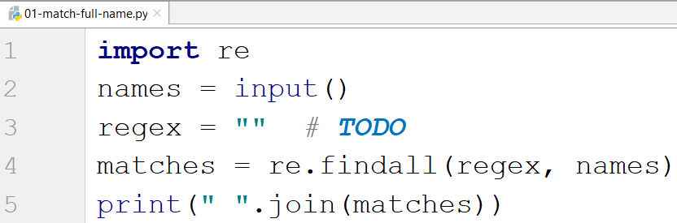

Examples
Input
Peter Smith, peter smith, Peter smith, peter Smith, PEter Smith, Peter SmIth, Lily Everett
Output
Peter Smith Lily Everett

Match Phone Number
Write a regular expression to match a valid phone number from Sofia. After you find all valid phones, print them on the console, separated by a comma and a space ", ".

Compose the Regular Expression
A valid number has the following characteristics:
- It starts with "+359"
- Then, it is followed by the area code (always 2)
- After that, it is followed by the number itself:
  - The number consists of 7 digits (separated in two groups of 3 and 4 digits respectively).
- The different parts are separated by either a space or a hyphen ('-').
You can use the following RegEx properties to help with the matching:
- Use quantifiers to match a specific number of digits
- Use a capturing group to make sure the delimiter is only one of the allowed characters (space or hyphen) and not a combination of both (e.g. +359 2-111 111 has mixed delimiters, it is invalid). Use a group backreference to achieve this.
- Add a word boundary at the end of the match to avoid partial matches.
- Ensure that before the '+' sign there is either a space or it is the beginning of the string.
You can use the following table of values to test your RegEx:
Match ALL of these | Match NONE of these
+359 2 222 2222  +359-2-222-2222 | 359-2-222-2222, +359/2/222/2222, +359-2 222 2222  +359 2-222-2222, +359-2-222-222, +359-2-222-22222

Implement the Solution
Import re, create your pattern, read the text, use the findall() method and print the result:
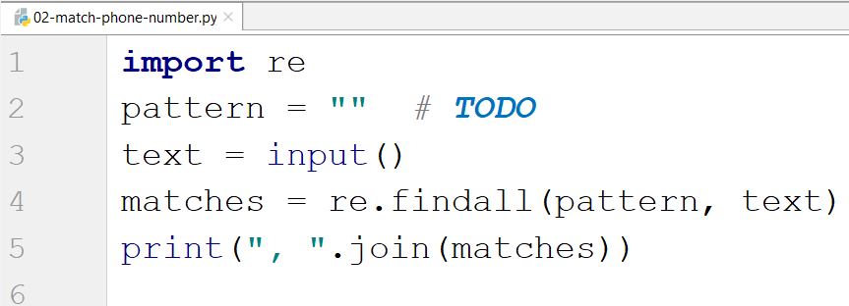

Examples
Input
+359 2 222 2222,359-2-222-2222, +359/2/222/2222, +359-2 222 2222 +359 2-222-2222, +359-2-222-222, +359-2-222-22222 +359-2-222-2222
Output
+359 2 222 2222, +359-2-222-2222

Match Dates
Write a program, which matches a date in the format "dd{separator}MMM{separator}yyyy". Use capturing groups in your regular expression.

Compose the Regular Expression
Every valid date has the following characteristics:
- Always starts with two digits, followed by a separator
- After that, it has one uppercase and two lowercase letters (e.g. Jan, Mar).
- After that, it has a separator and exactly 4 digits (for the year).
- The separator could be one of these symbols: a period ("."), a hyphen ("-") or a forward slash ("/").
- The separator must be the same for the whole date (e.g., 13.03.2016 is valid, 13.03/2016 is NOT). Use a group backreference to check for this.
You can follow the table below to help with composing your RegEx:
Match ALL of these | Match NONE of these
13/Jul/1928, 10-Nov-1934, 25.Dec.1937 | 01/Jan-1951, 23/sept/1973, 1/Feb/2016
Use capturing groups for the day, month, and year.
Since this problem requires more complex RegEx, which includes named capturing groups, we will take a look at how to construct it:
- First off, we do not want anything at the start of our date, so we're going to use a word boundary "\b":
- Next, we are going to match the day, by telling our RegEx to match exactly two digits, and since we want to extract the day from the match later, we're going to put it in a capturing group:
- Next comes the separator – either a hyphen, period or forward slash. We can use a character class for this:
Since we want to use the separator, we matched here to match the same separator further into the date, we're going to put it in a capturing group:
- Next comes the month, which consists of a capital Latin letter and exactly two lowercase Latin letters:
- Next, we are going to match the same separator we matched earlier. We can use a backreference for that:
- Next up, we are going to match the year, which consists of exactly 4 digits:
- Finally, since we do not want to match the date if there's anything else glued to it, we're going to use another word boundary for the end:
Now it is time to find all the valid dates in the input and print each date in the following format: "Day: {day}, Month: {month}, Year: {year}", each on a new line.

Implement the Solution
First, import re, create the pattern, and read the text:
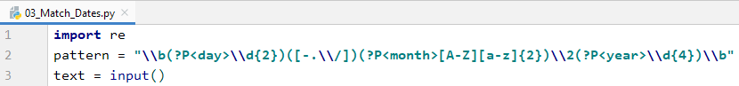
Then, we find all the matches:
Now in matches we have the following::
- We have an array of matches
- Each match has a tuple of all the matches (day, separator, month, year)
So, we print each match in the right format

Examples
Input
13/Jul/1928, 10-Nov-1934, , 01/Jan-1951,f 25.Dec.1937 23/09/1973, 1/Feb/2016
Output
Day: 13, Month: Jul, Year: 1928
Day: 10, Month: Nov, Year: 1934
Day: 25, Month: Dec, Year: 1937

Match Numbers
Write a program which finds all integer and floating-point numbers in a string.

Compose the Regular Expression
A number has the following characteristics:
- Has either whitespace before it or the start of the string (match either ^ or what's called a positive lookbehind). The entire syntax for the beginning of your RegEx might look something like "(^|(?<=\s))".
- The number might or might not be negative, so it might have a hyphen on its left side ("-").
- Consists of one or more digits.
- Might or might not have digits after the decimal point
- The decimal part (if it exists) consists of a period (".") and one or more digits after it. Use a capturing group.
- Has either whitespace before it or the end of the string (match either $ or what's called a positive lookahead). The syntax for the end of the RegEx might look something like "($|(?=\s))".
Let's see how we would translate the above rules into a regular expression:
- First off, we need to establish what needs to exist before our number. We can't use \b here, since it includes "-", which we need to match negative numbers.
Instead, we'll use a positive lookbehind, which matches if there's something immediately behind it. We'll match if we're either at the start of the string (^), or if there's any whitespace behind the string:
- Next, we'll check whether there's a hyphen, signifying a negative number:
Since having a negative sign isn't required, we'll use the "?" quantifier, which means "between 0 and 1 times".
- After that, we'll match any integers – naturally, consisting one or more digits:
- Next, we'll match the decimal part of the number, which might or might not exist (note: we need to escape the period character, as it's used for something else in RegEx):
- Finally, we're going to use the same logic for the end of our string as the start – we're going to match only if the number has either a whitespace or the end of the string ("$"):
You can follow the table below to help with composing your RegEx:
Match ALL of these | Match NONE of these
1 -1 123 -123 123.456 -123.456 | 1s s2 s-s -1- _55_ s-2 s-3.5 s-1.1
Find all the numbers from the string and print them on the console, separated by spaces.

Implement the Solution
Now that we've written our regular expression, we can start by putting it in a variable and extracting the matches:
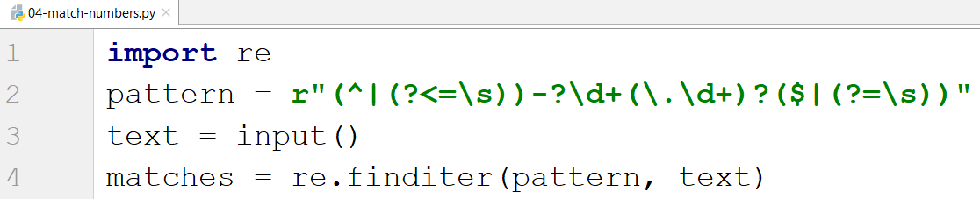
After that, it's only a matter of printing the numbers, separated by spaces:
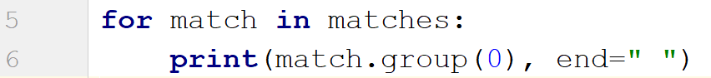

Examples
Input | Output
1 -1 1s 123 s-s -123 _55_ _f 123.456 -123.456 s-1.1 s2 -1- zs-2 s-3.5 | 1 -1 123 -123 123.456 -123.456

